

St Mary Magdalene Church
Canning Road warmly invites you to our
Christingle Celebration for all ages
at 4.00 pm on
Sunday 7th December 2025
The Christingle Service will have activities, carols and a story.
It’s a joyful celebration that brings families and communities together to share the light of Jesus and spread a message of hope.

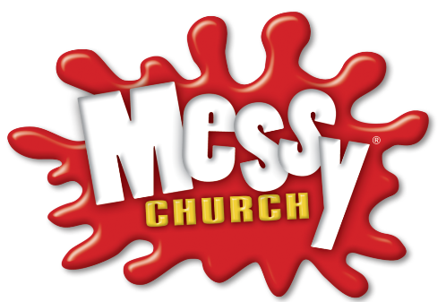
Come and find out what each part of the Christingle means and help make your own. There will be Christmas treats to eat and drink after the service.



www.stmmm.org.uk

