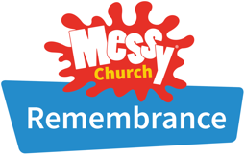

Games

Fun

Come and join us
on Sunday 8th November 2026
from 4.00 pm – 5.30 pm
Stories
Music
at St Mary Magdalene Church Hall,
Canning Road, CR0 6QD

For all ages of the family,
Food
Come along, bring a friend!
Crafts

We welcome you to come and join us.
It’s free and a great way to meet people, have fun and to enjoy finding out a bit more about God in a relaxed way together.
Come for games, stories, singing, food and activities to do.

You’ll find us halfway down Canning Road.
www.stmmm.org.uk



